# ActiveNet Fee Contracts

When ActiveNet processes a receipt, it assesses fees to either the consumer or the org. The fee structure is part of the contractual agreement between Active and the org, and is represented in ActiveNet as one or more "fee contracts". The fee contract system was initially quite simple, but over the years has become quite flexible/complex, as sales has requested many changes to allow different fee contract models.

This document describes how fees are computed on the basis of fee contracts. It begins by describing a very simple underlying model, then describes progressively additional options in fee contracts and how they operate.

# Fee contract design

## Basic fee model

There are three types of fees charged by ActiveNet. The following table gives an overview of the three types of fees:

|  |  |  |
| --- | --- | --- |
| Type of fee | Staff or consumer transactions | Based on |
| Transaction fee | Staff transactions -- unless "Apply processing fees to staff transactions?" is selected in fee contract, in which case transaction fees are not assessed, processing fees (below) are assessed instead. | The total of all payments which bring cash into the org, including:   * Cash * Check * Credit card * ECP * Gift certificate * Debit card |
| Credit card fee | Staff transactions.  Note: If "Record absorbed processing fees as transaction fees" is enabled then credit card fee will also be applied to Consumer transactions, reducing the transaction fee applied. | The amount of credit card, debit card, and ECP payments |
| Processing fee  (also called "convenience fee") | Consumer transactions.  Staff transactions -- if "Apply processing fees to staff transactions?" is selected in fee contract. | The entire amount of the receipt, regardless of how paid.  An optional exception will exclude payment from account.  If multiple fee contracts apply to line items on the receipt, then the processing fee is computed independently for each contract. |

* In general, fees are never refunded. If a transaction fee is assessed on an enrollment, and the enrollment is refunded, the transaction fee is not refunded to the org.
* However, if a receipt is voided, all the fees charged to the org are reversed by the void.

## Fee contracts

The mechanism for configuring fee rates in ActiveNet is the Fee Contract. Fee contracts are shown on the Web Admin menu, and are only editable by Active staff through the ActiveNet portal.

Every site has at least one fee contract, which is the default fee contract. Additional fee contracts may be configured and assigned to specific types of products -- more about that later.

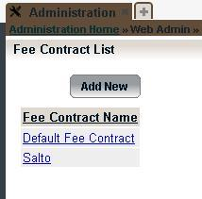

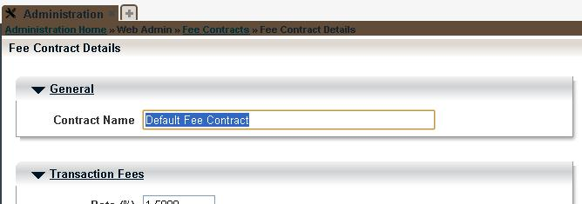

## Transaction fee computation

Transaction fees are applied to all moneys collected by the organization through staff transactions (not just credit card transactions).

Transaction fee configuration and computation is very simple:

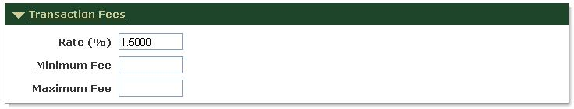

* There is a single flat rate for the transaction fee (shown here at 1.5%, which is a very common default).
* In addition, a minimum and maximum value of the fee can be configured. The minimum and maximum apply at the fee contract level -- if more than one fee contract is involved in a transaction, the payments on each are separately subject to the their respective minimums and maximums.
* Note that no transaction fees are applied to refunds.

## Credit card fee computation

Credit card fees are applied to all moneys collected by the organization through staff transactions, either by credit card, debit card, or ECP payments. The fee structure is separately configurable for credit card payments, debit card payments, and ECP payments, although both are recorded internally as "credit card fees".

Credit card fee configuration and computation works as follows:

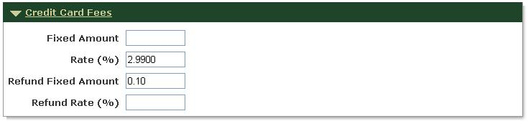

* For sales (positive payments), the fee is the sum of a fixed amount and a percentage of the payment. In the example above, there is no fixed amount, so the credit card fee is 2.99% of the credit card moneys collected.
* A separate pair of numbers configures the fee charged on credit card refunds. In the example above, there is no percentage, so the credit card fee is $.10 regardless of the refund amount.

Debit card fees and ECP fees have the same setup options which can also be configured.

Note: If the Processing Fee "**Record absorbed processing fees as transaction fees"** option is enabled, then when an online transaction is paid with CC/ECP/Debit Card the calculated processing fee is adjusted in order to allocate the appropriate amount to CC/ECP/Debit Card fee. For example, if the calculated processing fee for a $100 online transaction is $4.75, and the credit card fee would be $2 (if this was a staff-side Transaction Fee) then $2 will be recorded as the credit card fee and $2.75 will be recorded as the transaction fee (not processing/convenience fee). The total fee $4.75 is unchanged but the amounts are recorded differently.

## Processing fee computation

Processing fees (also called convenience fees) are normally charged on public transactions, although they can optionally be applied to staff transactions, instead of transaction and credit card fees, by enabling the "Apply processing fees to staff transactions" option.

Processing fee configuration and computation work as follows:

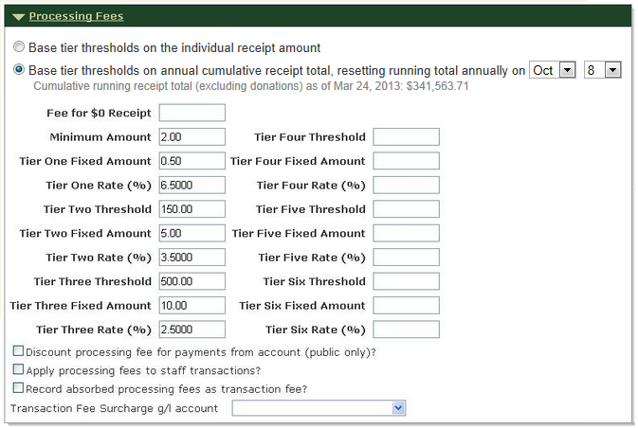

* The Tier <n> Threshold value can be configured to be either a per-receipt total value or cumulative receipt total for the organization. If a per-receipt value then the total payment amount for any given receipt will determine which tier processing fees will be applied. If cumulative value then the annual receipt total for the organization (less donations, and ignoring refund offsets) is used to determine which tier processing fees to apply to any given transaction.
* The basic fee structure is a tiered system with up to 6 tiers. Most commonly, three tiers are configured as above, based on the same fee model as RegCenter. In the example above:
  + For payments up to $150, the fee is $2.00 + 6.5% of the payment amount.
  + For payments up from $150 to $500, the fee is $5.00 + 3.5% of the payment amount.
  + For payments over $500, the fee is $10.00 + 2.5% of the payment amount.
* The fee calculated is also subject to a minimum, in this case $2.00.
* For free receipts, such as enrollments in fee activities, the minimum normally applies. However, an alternate "Fee for $0 receipt" can be configured.
* Note that no processing fees are applied to refunds.

In addition, the following options control how processing fees are applied:

* **Discount processing fee for payments from account (public only):** Normally, the convenience fee is applied to payments from account. This results in a fee being charged on the payment when an overpayment is used to put money in the account, and a second fee being assessed when the payment from account is made. This option exempts payments from account from being charged a processing fee. Note that this only applies to public transactions -- if processing fees are configured for staff transactions, payment from account is still assessed the processing fee.
* **Apply processing fees to staff transactions:** Normally, staff transactions are charged a transaction fee and credit card fee instead of a processing fee. This option is used to use processing fees for staff transactions, which allows additional flexibility in configuring the fee rates for staff transactions. The processing fee will be assessed instead of transaction fees; if credit card fees are configured, they will still be charged.
* **Record absorbed processing fees as transaction fees:** Normally, when processing fees are absorbed, a discount charge is made to a special system account "Processing Fee Account". This has the effect of causing the processing fee to show up in revenue reports, unlike the other charges. This option causes any absorbed processing fees to be recorded as transaction fees, which are not reported, instead of as processing fees. If this option is enabled, then a credit card fee will also be recorded (if payment by CC/ECP) and the recorded transaction fee reduced accordingly.
* **Transaction fee surcharge G/L account:** When processing fees are assessed on staff transactions, and there is a surcharge, the surcharge is added to the receipt as a special line item. This setting allows us to configure which G/L account is used for this "fee surcharge transaction".

## Absorbing processing fees

Processing fees can be assessed in two ways:

* Surcharged, so the consumer pays an addition amount for the fee, which appears on their receipt.
* Absorbed, so the consumer pays no additional amount, and no fee appears on the receipt. In this case, Active charges the org by reducing their remittance by the amount of the fee.

There is considerable flexibility in determining whether processing fees are surcharged, absorbed, or a combination, as described below:

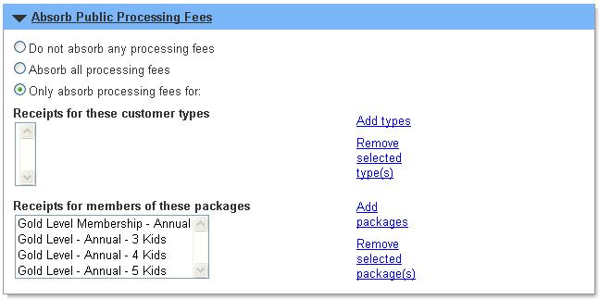

The above section specifies at an overall level whether fees are absorbed or not. The options are:

* Do not absorb (surcharge the fee).
* Absorb the fee.
* Absorb fees for specific customer types, or members of specific membership packages. ??? This is based on the payer(s) on the receipt.
* (Not shown on screen shot above) For non-default contracts, to use the setting from the default contract.

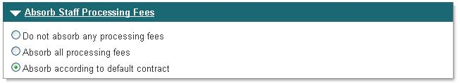

The above section only appears if the option "Apply processing fees to staff transactions". Note that for staff processing fees, there are no options to selectively apply based on customer type or membership.

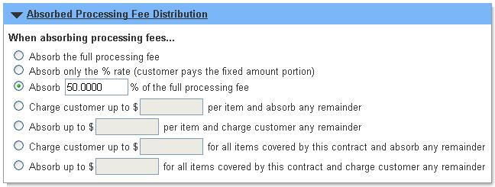

Finally, the above section allows for a combination of absorbing and surcharging fees.

## Multiple fee contracts

For additional flexibility, an ActiveNet org may have more than one fee contract:

* The first contract which is always in ActiveNet is the "default fee contract" and cannot be deleted.
* Any number of "secondary fee contracts" fee contracts may be created.
* Secondary contracts only specify the processing fee options, not transaction or credit card fees.

The default fee contract always applies, unless one of the secondary contracts is applied as a result of the following configuration options:

First, a secondary contract may be selected based on the type of product (inventory) purchased, and whether it was purchased on the staff or public side:

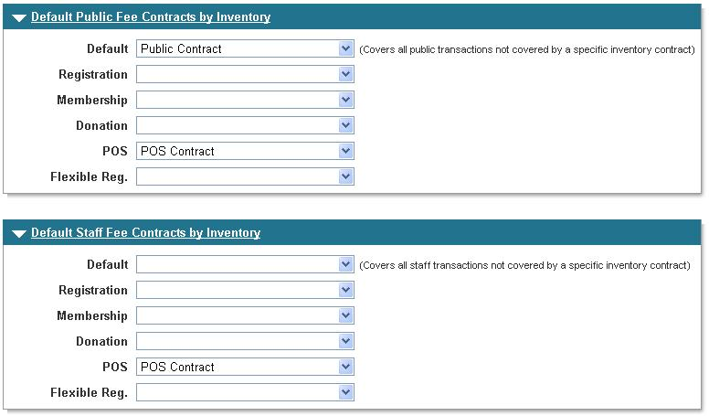

At a more granular level, a non-default fee contract may be assigned to specific inventory of these types:

* Activities
* Campaigns
* Daycare programs
* Membership packages
* POS products

The following screen shows settings from an Activity:

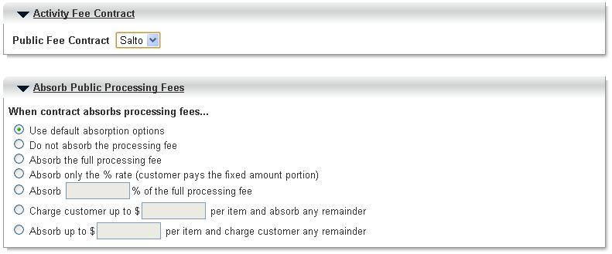

* A specific secondary contract can be selected.
* Assuming the contract absorbs processing fees, the amount absorbed can be configured on a per-product basis.

## Operation of multiple contracts within a receipt

Transaction and credit card fees, if configured, are controlled by the default fee contract, and apply to the entire receipt. Multiple contracts only effect the computation of processing fees, as described below:

* Each transaction (receipt line item) is assigned to a fee contract as follows:
  + If a contract is specified for a specific inventory item, that contract is used. E.g., if the activity being enrolled in has a contract specified.
  + Otherwise, if a default contract is specified for a specific inventory type, and for the location of the transaction (staff or public), that contract is used. E.g., if this is donation on a public transaction, and a default public donation contract is specified.
  + Otherwise, if a default contract is specified for the location (staff or public), that contract is used.
  + Otherwise, the default contract is used.
* Once a fee contract has been assigned to each transaction, the transactions are totalled by fee contract, and the amount of the processing fee is computed for each contract.
* If the fee contract calls for payment from account to be exempt from processing fees, the processing fee is reduced by the percentage of payments which are from account.
* Internally, this processing fee is then prorated against all the transactions for that fee contract.

# Database implementation of fees

All of the setting described above, and shown in the screenshots, are recorded in the FeeContracts table. This section describes how the fees charged are recorded in the database.

## Recording fees – overview

This section gives a narrative overview of how and why Active’s fees are recorded where they are. Later sections will show examples to clarify this.

When the fee system was first built, the decision was made to not record the fees as ReceiptDetails with corresponding GL records. There were two reasons for this:

* Because at that time, ActiveNet was the same code as Safari’s Recware Online system, there was concern about the risk of changing accounting reports or how accounting data was recorded.
* At the time, Active’s management wanted to minimize the visibility to the orgs of how much ActiveNet was costing. We had to provide an auditing report for Active’s remittances to the org -- the Agency Payment report – so the three fees were reported there. But they weren’t recorded in the GL, so didn’t appear as expenses on the Net Revenue report, for example.

Since the requirement was simply to provide auditing reports, the convenience fees were added as columns to the ReceiptHeaders table. The fees were just computed on the basis of overall receipt data, so this made sense. The remittance data was fed into EBS from the ReceiptHeaders table, and the Agency Payment report just used this same data.

Later, when site-specific remittance remittance was implemented, it was possible for different transactions to be remitted to different sites. To support this, the convenience fees were also prorated to new columns on the Transactions table, and the remittance fed into EBS and the Agency Payment report use the data from the Transactions table (although the aggregate data is still in the ReceiptHeaders table)

Later, it became possible for a transaction to have receipt details (e.g., from activity fees) for different sites, site-specific remittance would require computing and remitting fees on a receipt detail level. To support this, the convenience fees were also prorated to new columns on the ReceiptDetails table, and the remittance fed into EBS and the Agency Payment report use the data from the ReceiptDetails table. (This is an org-level option in the SystemInfo table).

In all of these cases, there are no GL records written. They are not treated like expenses.

## Example: Credit card and transaction fees

Here is an example of how transaction and credit card fees are recorded for a single receipt. In this case, there are two transactions, and one of the transactions has three receiptdetails.

|  |  |  |  |  |  |  |
| --- | --- | --- | --- | --- | --- | --- |
| **TABLE** | **REC_NUM** | **CC_AMT** | **TRX_FEE** | **CC_FEE** | **CONV_FEE** | |
| ReceiptHeaders | 1000211.022 | $372.00 | $2.42 | $6.33 | $0 |  |
|  |  |  |  |  |  |  |
| **TABLE** | **PMT_TYPE** | **PMT_AMT** |  |  |  |  |
| ReceiptPayments | CC | $372.00 |  |  |  |  |
|  |  |  |  |  |  |  |
| **TABLE** | **TRX_ID** | **CC_AMT** | **TRX_FEE** | **CC_FEE** | **SURC_FEE** | **ABS_FEE** |
| Transactions | 2463 | $372.00 | $2.42 | $6.33 | $- | $- |
| Transactions | 2464 | $- | $- | $- | $- | $- |
|  |  |  |  |  |  |  |
| **TABLE** | **TRX_ID** | **CC_AMT** | **TRX_FEE** | **CC_FEE** | **SURC_FEE** | **ABS_FEE** |
| ReceiptDetails | 2463 | $300.02 | $1.95 | $5.11 | $- | $- |
| ReceiptDetails | 2463 | $36.01 | $0.23 | $0.61 | $- | $- |
| ReceiptDetails | 2463 | $35.97 | $0.24 | $0.61 | $- | $- |
| ReceiptDetails | 2464 | $- | $- | $- | $- | $- |

* CC_AMT
  + The ReceiptHeader shows the CC_AMT, which is the amount paid by electronic payments processed by Active: credit card, debit card and EFT.
  + The Transaction and ReceiptDetail records show the CC_AMT prorated against the individual transactions and RDs.
  + The ReceiptHeader shows the actual payment type and payment amount. In this case, it’s a CC payment.
* TRX_FEE and CONV_FEE
  + The ReceiptHeader shows the overall transaction fee (TRX_FEE) and credit card fee (CC_FEE) applied to this receipt.
  + The Transaction and ReceiptDetail records show the fees prorated against the individual transactions and RDs

## Example: Surcharged convenience fee

|  |  |  |  |  |  |  |
| --- | --- | --- | --- | --- | --- | --- |
| **TABLE** | **REC_NUM** | **CC_AMT** | **TRX_FEE** | **CC_FEE** | **CONV_FEE** | |
| ReceiptHeaders | 1000001.001 | $40.00 | $- | $- | $3.10 |  |
|  |  |  |  |  |  |  |
| **TABLE** | **PMT_TYPE** | **PMT_AMT** |  |  |  |  |
| ReceiptPayments | CC | $40.00 |  |  |  |  |
|  |  |  |  |  |  |  |
| **TABLE** | **TRX_ID** | **CC_AMT** | **TRX_FEE** | **CC_FEE** | **SURC_FEE** | **ABS_FEE** |
| Transactions | 624 | $20.00 | $- | $- | $1.55 | $- |
| Transactions | 625 | $20.00 | $- | $- | $1.55 | $- |
|  |  |  |  |  |  |  |
| **TABLE** | **TRX_ID** | **CC_AMT** | **TRX_FEE** | **CC_FEE** | **SURC_FEE** | **ABS_FEE** |
| ReceiptDetails | 624 | $20.00 | $- | $- | $1.55 | $- |
| ReceiptDetails | 625 | $20.00 | $- | $- | $1.55 | $- |

* CC_AMT
  + The ReceiptHeader shows the CC_AMT, which is the amount paid by electronic payments processed by Active: credit card, debit card and EFT.
  + The Transaction and ReceiptDetail records show the CC_AMT prorated against the individual transactions and RDs.
  + The ReceiptHeader shows the actual payment type and payment amount. In this case, it’s a CC payment.
* TRX_FEE and CONV_FEE
  + The ReceiptHeader shows the overall transaction fee (TRX_FEE) and credit card fee (CC_FEE) applied to this receipt.
  + The Transaction and ReceiptDetail records show the fees prorated against the individual transactions and RDs

In this case, the pattern is basically the same as for transaction and credit card fees.

## Example: Absorbed convenience fee

|  |  |  |  |  |  |  |  |
| --- | --- | --- | --- | --- | --- | --- | --- |
| **TABLE** | **REC_NUM** | **CC_AMT** | **TRX_FEE** | **CC_FEE** | **CONV_FEE** | |  |
| ReceiptHeaders | 1000001.001 | $242.52 | $- | $- | $9.98 |  |  |
|  |  |  |  |  |  |  |  |
| **TABLE** | **PMT_TYPE** | **PMT_AMT** |  |  |  |  |  |
| ReceiptPayments | CC | $242.52 |  |  |  |  |  |
|  |  |  |  |  |  |  |  |
| **TABLE** | **TRX_ID** | **CC_AMT** | **TRX_FEE** | **CC_FEE** | **SURC_FEE** | **ABS_FEE** |  |
| Transactions | 6003 | $242.52 | $- | $- | $2.50 | $7.48 |  |
|  |  |  |  |  |  |  |  |
| **TABLE** | **TRX_ID** | **CC_AMT** | **TRX_FEE** | **CC_FEE** | **SURC_FEE** | **ABS_FEE** | **ACCT** |
| ReceiptDetails | 6003 | $(7.47) | $- | $- | $- | $7.48 | System:ConvenienceFees |
| ReceiptDetails | 6003 | $235.00 | $- | $- | $2.35 | $- | SchoolTuition |
| ReceiptDetails | 6003 | $14.99 | $- | $- | $0.15 | $- | SchoolLabFees |

In this case, there is a significant difference:

* The overall convenience fee is reported in the RH as $9.98.
* In this case, the convenience fee was only partially absorbed. So the TR shows $2.50 of it was surcharged, and $7.48 was absorbed.
* This transaction had two RDs for regular fees, for accounts “SchoolTuition” and “SchoolLabFees”. They have the surcharged convenience fee amount from the transaction prorated to them.
* For the absorbed convenience fee, the system created a new RD, for the account “ConvenienceFees”.

# Reporting of fees

## General summary

* As stated above, the original design intent was to hide the fees as much possible, except on the remittance reconciliation reports (Agency Payment and Active Income).
* Surcharged convenience fees do not effect revenue; the surcharge only effects Active’s income. Only the remittance reports include this in their calculations, so that’s fine.
* The absorbed convenience fees, transaction fees and credit card fees all come out of the organization’s nominal charge for programs and therefore reduce revenue.
* Therefore, organizations naturally want to see the impact of fees on their revenue, so over time, report after report has been modified to include fees. However, this has only been reactive, so reports as a whole are inconsistent in whether they take fees into account, and which fees.
* For some reason, absorbed convenience fees were implemented as actual accounting events, with receipt details and GL records; this means they can naturally appear in revenue reports. However, transaction and credit card fees are only implemented as annotations on receipt details, so it much more complex to make adjustments for them in reports.

In terms of specific inconsistencies:

* As a general point, absorbed convenience fees have the same effect as transaction and credit card fees (which are always absorbed), so either all or none of them should be used in a report. This is not always the case.
* In most cases, fees are used in reports to reduce revenue, which makes sense. However, they are also used in reports like Cash Receipts, treating them like refunds, which is probably wrong.

## Reports

I analyzed the report source code to determine which reports actually use the convenience fee or the transaction fee. They are listed below. It’s possible it’s not entirely accurate, because I just scanned all the reports for certain column names: convenience_fee, absorbed_convenience_fee, transaction_fee and credit_card_fee. I didn’t run the reports or otherwise study them in more detail.

I’ve highlighted certain cells which are questionable for a few reasons:

* (Yellow) If a report includes absorbed convenience fees, it probably should include transaction/credit card fees in making the same adjustments.
* (Orange) Fees probably shouldn’t be adjusted on receipt reports, because they’re not cash, but only on revenue reports.

|  |  |  |  |
| --- | --- | --- | --- |
| **Report** | **Uses surcharged convenience fee** | **Uses absorbed convenience fee** | **Uses transaction & credit card fees** |
| Active Income | y | y | y |
| Activity Revenue |  | y | y |
| Agency Distribution | y | y | y |
| Agency Payment | y | y | y |
| Customer Statement |  | y |  |
| Cash Receipts |  | y |  |
| Customer Statement |  | y | y |
| Daycare Revenue |  |  | y |
| Net Revenue |  | y | y |
| POS Sales |  | y |  |
| Receipt (staff-side) |  | y |  |
| Reprint Receipt |  | y |  |
| Tax Receipt |  |  | Y |

The following reports don’t use any of the fees, but probably are revenue or receipt reports, and probably should to be consistent with

|  |  |
| --- | --- |
| **Report** | **Notes** |
| Account distribution report | Won’t include Trx/CC fees |
| Actuals vs. Budgeted Profit/Loss |  |
| Cash Distribution by Account Detail | ANE-26714 / INC2272631 |
| Departmental Revenue Report | Won’t include Trx/CC fees |

# Research material

I've recorded here some of the research material used to compile and validate information on this page.

## Queries against production sites

In order to understand the current system, and determine which of the various options were actually used, I used the portal to run a set of queries against the production systems and brought that into Excel for analysis. The [spreadsheet](https://activexperience.active.local/servlet/JiveServlet/download/248799-16-104261/2011-06-08%20Fee%20contracts.xlsx) is attached to this page.

## Jira tickets

The following Jira tickets added features to the fee contract system:

|  |  |  |  |
| --- | --- | --- | --- |
| Jira ticket | Version | Title | Associated SBS page |
| [ANE-2722](http://jira.active.com/jira/browse/ANE-2722) | 13.2 | CLASS GAP - PIN/Debit Support - 7. Fee contract and other financial system support | [http://sbs.active.com/docs/DOC-259929](https://activexperience.active.local/docs/DOC-259929) |
| [ANE-7780](http://jira.active.com/jira/browse/ANE-7780) | 13.2 | YMCA GAP - Threshold pricing model fee contract | [http://sbs.active.com/docs/DOC-262316](https://activexperience.active.local/docs/DOC-262316) |
| AN-19463 | 10.4 | Rename Convenience Fees for Visa compliance  To make a long story short, "Convenience Fees" is terminology that is causing us some headaches already - among customers who are cognizant of Visa compliance regulations that define the ways in which fees so named can be applied to Visa payments. (For one thing, according to Visa, such fees must be flat - i.e. without regard to the amount of the base payment, which obviously is not the case with usual ActiveNet fee contracts.)  The primary output of conferring with Active's legal team is that, essentially, we can't call these fees "Convenience Fees" anymore - and we should prefer the term "Processing Fees" instead. | [http://sbs.active.com/docs/DOC-239730](https://activexperience.active.local/docs/DOC-239730) |
| [AN-18037](http://jira.active.com/jira/browse/AN-18037) | 10.3 | Wording change on Fee Contract configuration | <http://clearspace.activenetwork.com/docs/DOC-238043> |
| [AN-16486](http://jira.active.com/jira/browse/AN-16486) | 11.3/10.4 | Create Active staff profile (available via portal tool) exclusively for Fee Contract configuration |  |
| [AN-9881](http://jira.active.com/jira/browse/AN-9881) | 8.3 | Changes to Fee Contract management (Default contracts for inventory types)  This is being requested by the executive so that we can change the way we negotiate contracts with certain large customers - applying a flat rate to most transactions, with the exception of POS items. There is a secondary need to allow for donation amounts to be charged a lower rate, or charged no fee at all.   The idea is to require that agencies like these apply convenience fees globally (current functionality), and then use an enhanced system of default contracts - specified both for the type of inventory and for the context (online or off) - to configure the rates. | <http://clearspace.activenetwork.com/docs/DOC-134231> |
| [AN-9740](http://jira.active.com/jira/browse/AN-9740) | 8.3 | Support application of credit-card & ECP fees to public transactions  We need to be able to charge the agency distinct amounts for processing credit-card and ECP payments from the public site. (These charges are *always* absorbed by the agency.) Convenience fees will be continue to be applied (in terms of rates and absorption options) as configured. | <http://clearspace.activenetwork.com/docs/DOC-134166> |
| [AN-8502](http://jira.active.com/jira/browse/AN-8502) | 8.2 | Fee Configuration Changes: Add fees for ECP payments  Need an "ECP fees" section (similar to the "Credit Card Fees" configuration controls) | <http://clearspace.activenetwork.com/docs/DOC-134099> |
| [AN-6979](http://jira.active.com/jira/browse/AN-6979) | 8.2 | Add Fee Contract Selection to Packages, Programs & Products  Currently, the only type of ActiveNet inventory for which the user can select a particular fee contract is Activities, where there is a "Fee Contract" drop-down on the Change Activity Details page. It would be advantageous to add the same feature to the Details screens for Membership Packages and Daycare Programs, so that rates & absorption behaviour could be configured with more granularity. | <http://clearspace.activenetwork.com/docs/DOC-133906> |
| [AN-6445](http://jira.active.com/jira/browse/AN-6445) | 7.2 | Link donation campaigns to fee contracts to configure active fee calculation  Similar to how we can now link individual activities to a specific fee contract, the request is to add the ability to specify a particular contract to use for a given donation campaign. This will allow agencies to set specific convenience fee rates and absorption behaviours for each campaign if they desire.  Default behaviour for campaigns NOT linked to specific, non-default fee contracts will also be changed: Transaction, credit-card, and convenience fees in these cases will be calculated according to the default contract, with the exception that convenience fees paid online will ALWAYS be absorbed by the agency. | <http://clearspace.activenetwork.com/docs/DOC-133840> |
| [AN-5481](http://jira.active.com/jira/browse/AN-5481) | 7.2 | no convenience fee for using credit on account online  Org does not want convenience fee charged when their customer registers or pays for something using credit on account that was already charged a transaction fee. Org feels it is unfair to be hitting their customer twice with a fee if they have already paid it initially but not participated in the class. | <http://clearspace.activenetwork.com/docs/DOC-133736> |
| [AN-4840](http://jira.active.com/jira/browse/AN-4840) | 7.2 | [Modify net revenue report to hide convenience fee when absorbing](http://jira.active.com/jira/browse/AN-4840)  * Before executing the rest of the report, run the prorate_convenience_fees stored procedure (see ER25950 for more details) * Instead of using the GL_Ledger.Amount column, use the new GL_Ledger.Adjusted_Amount column. |  |
| [AN-4839](http://jira.active.com/jira/browse/AN-4839) | 7.2 | [Hide convenience fees when absorbing fees](http://jira.active.com/jira/browse/AN-4839) |  |
| [AN-23088](http://jira.active.com/jira/browse/AN-23088) |  | Fee Contract functionality - charge against payments as opposed to payment plans:  "I believe that this is only the case with absorbed Conv. Fees are used for Staff-side transactions, but this remains a serious issue from customers perspectives as the current behavior doesn't match our Legal-approved contracts." |  |
| [AN-21824](http://jira.active.com/jira/browse/AN-21824) |  | Change to Gift Certificate Fee Charges:  "A customer buys a Gift Certificate for $100 and the company is charged a transaction fee. Then whenever the gift certificate is used money moves from the liability account to the revenue account and since this is used as a payment, the company is charged a transaction fee again. We feel that this should work the same as a payment plan or deferred revenue account and the transaction fee should only be charged once." |  |
| [AN-21197](http://jira.active.com/jira/browse/AN-21197) |  | Transaction Fees on Net Revenue Report:  "In [~~AN-9544~~](http://jira.active.com/jira/browse/AN-9544), a feature that was released in ActiveNet 10.2 that shows the transaction, credit card and convenience fee is grouped together for a report. If customers run it for all gl accounts it does not show the fee for each account. Having this totaled together does not help large number of our clients because customers want to debit the fees from their third party financial software. The only way to do this with the current functionality is to run it for each facility, each activity and so on. As you can imagine this can be very time consuming process even for our smallest cusotmers.  The desired report is to show the fees for each line item.  This transaction fee should also reduce the net revenue column.  This should be triggered by the new "Include Third Party Fees in Net Revenue?"  All fees can be grouped under one column regardless of where transactions happened.  There is an option under ActiveStaff that controls if absorbed conv. fee are subtracted or not. This should validate to make sure absorbed conv. fees are not subtracted twice.(the current functionality does not do this). | [http://sbs.active.com/docs/DOC-246738](https://activexperience.active.local/docs/DOC-246738) |
| [AN-19925](http://jira.active.com/jira/browse/AN-19925) |  | Transaction Fees: Write general ledgere detail records for transaction fees:  Clients must currently write a manual general journal entry for the transaction fees associated with income. Can the system be modified to write to a system account the transaction fees? We have the Agency Distribution report, which shows the income "not realized" due to transaction fees, and we have the Convenience Fee Account, which does not appear to be used? |  |
| AN-19807 |  | Ability to make only certain facilities absorb convenience fees: |  |
| [AN-16738](http://jira.active.com/jira/browse/AN-16738) |  | Ability to pass CC fees onto the customer in OTC transactions:  Description of Business Need:  - New Visa rules say government agencies can pass CC costs onto the customer  - Need a way in fee configuration to accommodate this  - ie, absorption rules for CC fees  - This request is restricted to over-the-counter cc transactions |  |
| [AN-16591](http://jira.active.com/jira/browse/AN-16591) |  | Allow option to apply two Fee Contract options based on receipt/cart, instead of individual transactions: |  |
| [AN-15675](http://jira.active.com/jira/browse/AN-15675) |  | Adjust the ActiveNet Fee Contract Screen to prevent user error... |  |
| [AN-15359](http://jira.active.com/jira/browse/AN-15359) |  | Ability to Assign a Different Fee Contract for Certain Reservations  Description of Business Need:  - Customers who do lots of internal bookings may negotiate a separate fee contract for certain types of reservations  - Activity setup allows Active Staff to select a different fee contract for those activities  - To accomplish this, AN would need a similar setup, allowing for separate fee contract selection in ONE of the following:  - Schedule Type  - Event Type  - Fee Matrix Charge |  |
| [AN-13012](http://jira.active.com/jira/browse/AN-13012) |  | Absorb fees needs to be site-specific  Alberta Gymnastics has individual sites which want to absorb convenience fees. As of now you have to absorb fees on for all sites. Would be great if there was an option where absorbtion of convenience fees was done on a site level, really needed for these multi-site organizations. |  |
| [AN-12124](http://jira.active.com/jira/browse/AN-12124) |  | customer would like to see credit card fees in the agency payment distribution report |  |
| [AN-10958](http://jira.active.com/jira/browse/AN-10958) |  | Default Public Fee Contracts by Inventory  Default Public Fee Contracts by Inventory doesnt have Facility rentals options so if you have Apply convenience fees to staff transactions? then Facility online rentals dont get charged th online contract set up |  |
| [AN-10744](http://jira.active.com/jira/browse/AN-10744) |  | Option to not charge transaction fees for Gift Certificate payments  Staff-side only: Customer feels that charging them for selling the cert. and for using the cert. = "double dipping." |  |
| [AN-9741](http://jira.active.com/jira/browse/AN-9741) |  | subtract credit card and transaction fee from Revenue Report |  |
| [AN-8732](http://jira.active.com/jira/browse/AN-8732) |  | Allow non-default fee contracts to specify rates for transaction charges and payment-method-base fees  Basically, the request is for all fee contract records to have the same scope of functionality as the default record. |  |
| [AN-8731](http://jira.active.com/jira/browse/AN-8731) |  | Add ability to configure fees so that transaction fees are surcharged  Some agencies want to pass this to the customer, but can't use the method of applying convenience fees globally (because this option does not provide for context-specific absorption behaviours or payment-method-based fees). |  |